ITNPAI3 Artificial Intelligence for Natural Language Processing
Assignment 2: Sentiment Analysis Using Deep Learning

STUDENT ID: 3540289

Introduction
This report covers the design, implementation, and evaluation of two deep learning models built for sentiment analysis on the Dataset.
The central question is whether moving from classical feature engineering to neural representations produces a meaningful and consistent improvement, and where each approach falls short.

- Implemented a Bidirectional LSTM with attention and frozen GloVe embeddings (BiLSTM + GloVe) to represent the pretrained static embedding paradigm.

- Implemented a fine-tuned DistilBERT transformer to represent contextual embeddings.
They were chosen on purpose to be different in how they represent words and how they process sequences, so they are truly different methods and not just small variations of the same model.
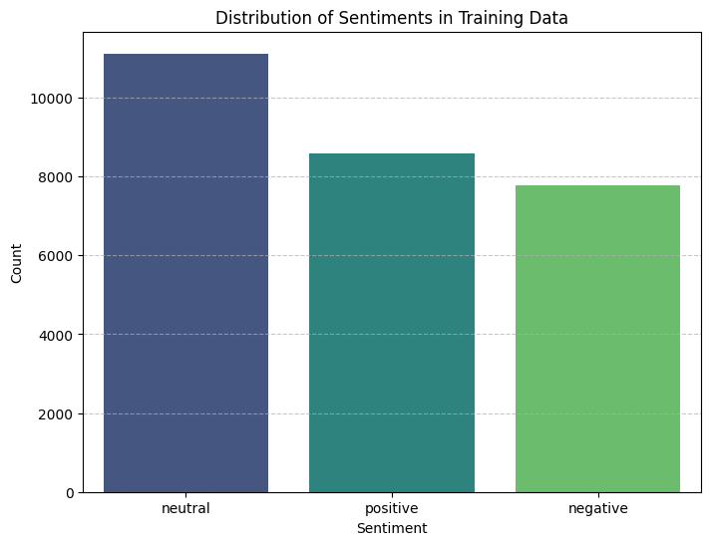
Preprocessing for Neural Sentiment Models:
The aim is not just to clean the text into simple tokens, but to keep important language clues that show sentiment, while removing unnecessary noise that could confuse the model or make it more complex.
A single unified preprocessing function was used across both models, with the exception that DistilBERT's WordPiece tokeniser handles its own subword splitting and casing internally.

Emoji and Emoticon Handling:
Emojis were converted to descriptive text descriptors using emoji.demojize() with space delimiters, so a smiling face emoji becomes a readable tag rather than raw Unicode.
Removing emojis completely would lose some of the strongest sentiment clues in social media text. Keeping them as raw symbols would create unknown words that GloVe cannot understand. Converting them into text labels is a balanced solution, because the model can recognise them as normal words while still keeping their meaning.
This decision is especially important for this dataset given its social media origin.
Negation and Contraction Handling:
Contractions were expanded before tokenisation using the contractions library. The motivation is straightforward: if "can't" is tokenised as a single unknown token, the model has no explicit signal that a negation occurred.
Expanding it to "can not" ensures "not" appears as a distinct token in the sequence, allowing the embedding layer to assign it appropriate weight. This is particularly important for the BiLSTM, which relies on token-level representations. DistilBERT's WordPiece tokeniser would split "can't" into subword units regardless, but consistent expansion is applied across both pipelines for clarity.
Case Normalisation and URL Replacement:
URLs and @mentions were replaced with simple tokens like <URL> and <USER>. These do not carry sentiment, and keeping them in their original form would create too many unique words that GloVe cannot recognise. Using placeholders keeps the sentence structure while removing unnecessary noise. DistilBERT also benefits because it sees consistent, predictable tokens instead of random text.
All text was converted to lowercase. This is important because GloVe embeddings are built on lowercase words, and using mixed case would cause many words to become unknown. The uncased version of DistilBERT was used for the same reason. Although lowercasing may lose small details, like capital letters showing strong emotion, it improves overall model performance by increasing word coverage.
Punctuation Treatment:
Sentence-boundary punctuation (! and ?) was retained because it carries genuine sentiment signal. Repeated punctuation was normalised to a single instance to avoid the vocabulary fragmenting into separate entries for "!", "!!", and "!!!". Other punctuation was removed. Preserving negation-adjacent punctuation (the apostrophe in contractions) was handled prior to removal by expanding contractions first.

Neural Input Representations
Pretrained Static Embeddings (GloVe 6B 100d)
GloVe 100-dimensional vectors were used to set up the embedding layer of the BiLSTM. Words found in GloVe were given their pretrained vectors, while unknown words were randomly assigned values. These embeddings were kept fixed during training, meaning the model could use them but not change them.
This was done on purpose because the dataset is too small to improve embeddings that were trained on a very large dataset. Keeping them fixed also reduces the risk of overfitting. However, GloVe was trained on formal text, so it may not fully capture informal meanings in social media. For example, words like “sick” may not reflect their slang sentiment.
Another limitation is that GloVe does not understand context. Each word always has the same meaning, so words like “not” are treated the same in every situation. This makes it harder for the BiLSTM to learn things like negation compared to models that use context-aware embeddings.

Contextual Embeddings (DistilBERT-base-uncased)
DistilBERT is a compressed version of BERT (66M parameters, 6 transformer layers, 12 attention heads) that retains approximately 97% of BERT's language understanding while being 40% smaller and 60% faster. Unlike GloVe, DistilBERT generates a different representation for each token depending on every other token in the sequence through multi-head self-attention. The word "not" in "I do not like this" receives a fundamentally different contextual embedding from the same word in "this is not bad".
The model was fully fine-tuned using AdamW with a small learning rate (2e-5), which helps it adapt without losing what it already learned. The final [CLS] token is used for classification through a simple two-layer head.
Unlike GloVe, the model captures sentiment within the representation itself. By the time the [CLS] vector is used, it already reflects relationships between words in the sentence, making it better at handling things like negation and emphasis.
Comparison of Representations:
GloVe uses fixed word meanings, so the BiLSTM has to learn how words combine to express sentiment. DistilBERT understands context, so it can capture how words change meaning in a sentence. This is why DistilBERT performs better (78.6% vs 67.4%).
GloVe is still useful because it is simple, fast, and easy to use. The lower performance here is mainly because it was trained on formal text, which does not match social media language well.

Model Training and Evaluation
BiLSTM with Attention:
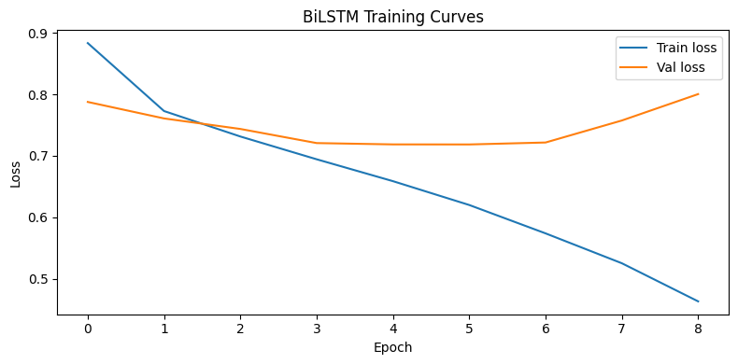
The BiLSTM reads the text in both directions and combines the information, so it can understand context better. This is useful for sentiment because some words only make sense after seeing what comes next, like “not bad”.
An attention layer is added so the model can focus more on important words instead of treating all words equally. This helps it pick out key sentiment words even in longer sentences. Padding tokens are ignored so they do not affect the results.
Dropout (0.4) was used to reduce overfitting, and early stopping (patience of 3) was applied based on validation loss. The best model was saved and used for testing.
DistilBERT Classifier:
DistilBERT from the HuggingFace library was fine-tuned on the training data. It uses a 6-layer transformer and a classification head on the [CLS] token. The whole model was updated during training, so a low learning rate (2e-5) was used to keep the pretrained knowledge stable.
Few training evaluation after each epoch. This is enough because the model already starts with strong knowledge and learns quickly. More training could lead to overfitting.
Unlike BiLSTM, DistilBERT looks at all words at once using self-attention. This helps it capture relationships between words better, even if they are far apart in the sentence.
Hyperparameters
Parameter | BiLSTM + GloVe | DistilBERT
Embedding dimension | 100 (GloVe 6B) | 768 (pretrained)
Hidden / model size | 128 per direction (256 total) | 66M parameters
Attention | Single-head additive | 12-head self-attention (6 layers)
Dropout | 0.4 (post-attention) | 0.1 (default, all layers)
Max sequence length | 100 tokens | 128 tokens
Batch size | 32 | 16
Learning rate | 1e-3 (Adam) | 2e-5 (AdamW)
Epochs (max) | 20 (early stop) | 2–3
Early stopping patience | 3 epochs (val loss) | N/A — eval per epoch
Regularisation | Dropout + early stopping | Dropout + weight decay (AdamW)
Embedding training | Frozen (static GloVe) | Fine-tuned end-to-end
Data Splits and Training Procedure:
The dataset was split into 70% training, 15% validation, and 15% testing, with class balance maintained in each split. The validation set was used for tuning and early stopping, while the test set was only used for final evaluation.
For the BiLSTM, training and validation loss were tracked each epoch. Early stopping occurred at epoch 9, and the best model from epoch 6 (70.1% validation accuracy) was used. For DistilBERT, validation was done after each epoch, and training stopped at epoch 2 once the model had converged.
Results comparision with Assignment 1(LG, NB with TF-IDF)
Model | Embedding | Architecture | Accuracy | Weighted F1
Logistic Regression (Assign. 1) | TF-IDF | Linear | 0.707 | 0.704
Naive Bayes (Assign. 1) | TF-IDF | Naive Bayes | 0.653 | 0.630
BiLSTM + Attention (this work) | GloVe 6B 100d (static) | BiLSTM + Attention | 0.6735 | 0.6750
DistilBERT (this work) | Contextual (DistilBERT) | Transformer | 0.7858 | 0.7861
DistilBERT performed best, achieving 78.6% accuracy and 0.786 F1, clearly improving on earlier models. The BiLSTM reached 67.4% accuracy and 0.675 F1, slightly below the logistic regression baseline (70.7%).
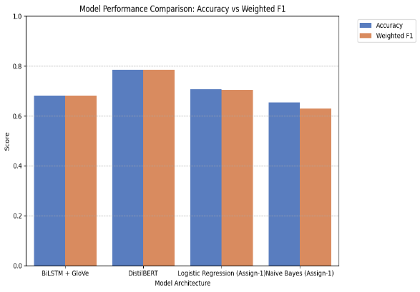
The BiLSTM likely underperformed for a few reasons. GloVe was trained on formal text, so it does not handle social media language well, leaving many words as unknown. Because the embeddings were frozen, the model could not adapt. Also, the BiLSTM is more complex than logistic regression, so it is more prone to overfitting on a small dataset. The attention layer also needs enough data to learn properly, which may not have been available.
The large performance gap (11.2%) shows the advantage of contextual embeddings. DistilBERT already understands language structure before training, while the BiLSTM has to learn everything from the dataset.

Error Analysis
Misclassified examples from the DistilBERT test set were grouped to understand common errors. Five main patterns were found.
Negation Handling:
The model works well when negation is close to the word it affects, like “not good”. It struggles when the sentence is longer and the negation is far from the target.
Mixed Sentiment (e.g. “but”, “however”):
In sentences with both positive and negative parts, the model often predicts based on the overall tone instead of the final opinion. Some of these cases are also unclear even for humans.
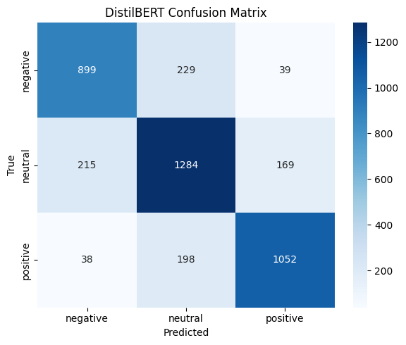
Sarcasm and Irony:
Sentences that use positive words to express negative meaning (e.g. “Oh great, another delay”) are often misclassified because the model reads the words literally.
Short Texts:
Very short texts like “ok” or “not bad” are hard to classify because there is little context to understand the real meaning.
Informal Language:
Words like “sick” or “wicked” can mean something positive in social media, but the model interprets them using their formal meaning, leading to errors.

Conclusion
This report compared two neural models with earlier TF-IDF baselines. DistilBERT performed best with 78.6% accuracy and 0.786 F1, clearly improving on previous results. The BiLSTM with GloVe reached 67.4%, below the logistic regression baseline (70.7%), mainly due to GloVe’s poor fit for social media language and its fixed word representations.
The error analysis showed common problems: long negation, mixed sentiment, sarcasm, short texts, and informal word meanings. Sarcasm was the hardest to handle, while negation and mixed sentiment could be improved with better training data.
Future improvements could include fine-tuning GloVe embeddings, using a model trained on social media like BERTweet, and increasing the dataset size. These areas highlight where performance can still be improved.

